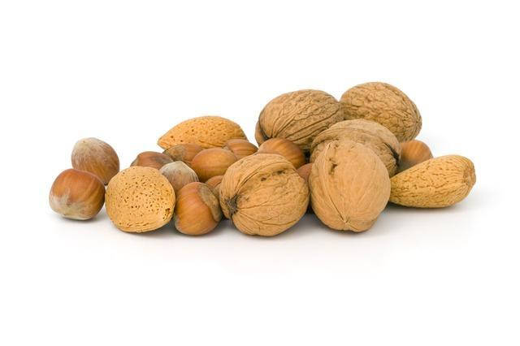
6th Grade Math in a Nutshell

Contact Information
Jacqueline Hart
hartja@wcsoh.org
614-797-8911 (voicemail)

Genoa Middle School
614-797-6500

Class Website
Through Google Classroom (has homework, keys, announcements, notes, and more)
*under your students google account (just click the square, apps in the top
right corner and click on classrooms)
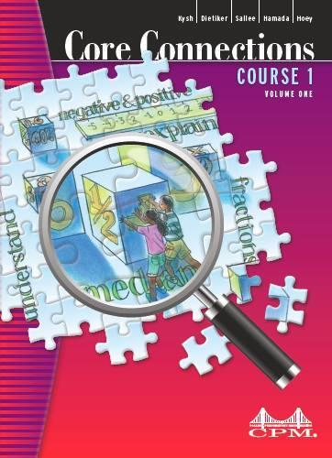

Textbook Website
ebooks.cpm.org
*homework help, lessons, notes, glossary, & more

Grades and Power School
Homework and Classwork | 10%
ALEKS | 10%
Team Reviews | 20%
Individual Test | 60%

Log in to PowerSchool through the district website. Expect homework every night. Grades are posted at least once a week.

