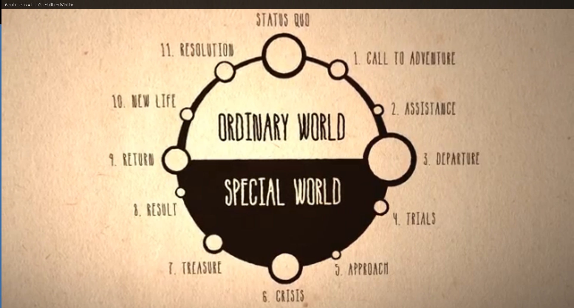

“The Hero’s Journey” – A Myth Analysis by Joseph Campbell

1:00 - Call to Adventure – Hero receives mysterious message or challenge.

2:00 – Assistance – Hero needs help from someone older and wiser.

3:00 – Departure – Hero leaves normal safe home and enters a world of adventure.

4:00 – Trials – Hero deals with difficult task, maybe slays a monster or escapes a trap.
5:00 – Approach – It is time for Hero to face his biggest fear.

6:00 – Crisis – Hero faces death, but survives.

7:00 – Treasure – Hero claims some treasure as a result of adventure, maybe special recognition.

8:00 – Result – What does the monster from the crisis scene do?

9:00 – Return – Hero returns to his ordinary world.

10:00 – New Life – Quest has changed Hero – He has outgrown old life.

11:00 – Resolution – All tangled plot lines are tied up.

12:00 – Status Quo – upgraded to new level. Nothing can be quite the same.

Name ________________________________

Now that you have considered The Hero’s Journey, you are being asked to choose a story of your own and decide if it fits into this pattern. Complete the following organizer with info from the story you chose.
Story__________________________
1:00 – Call to Adventure | 2:00 - Assistance
3:00 – Departure | 4:00 - Trials
5:00 – Approach | 6:00 Crisis
7:00 Treasure | 8:00 Result
9:00 Return | 10:00 New Life
11:00 – Resolution | 12:00 Status Quo

