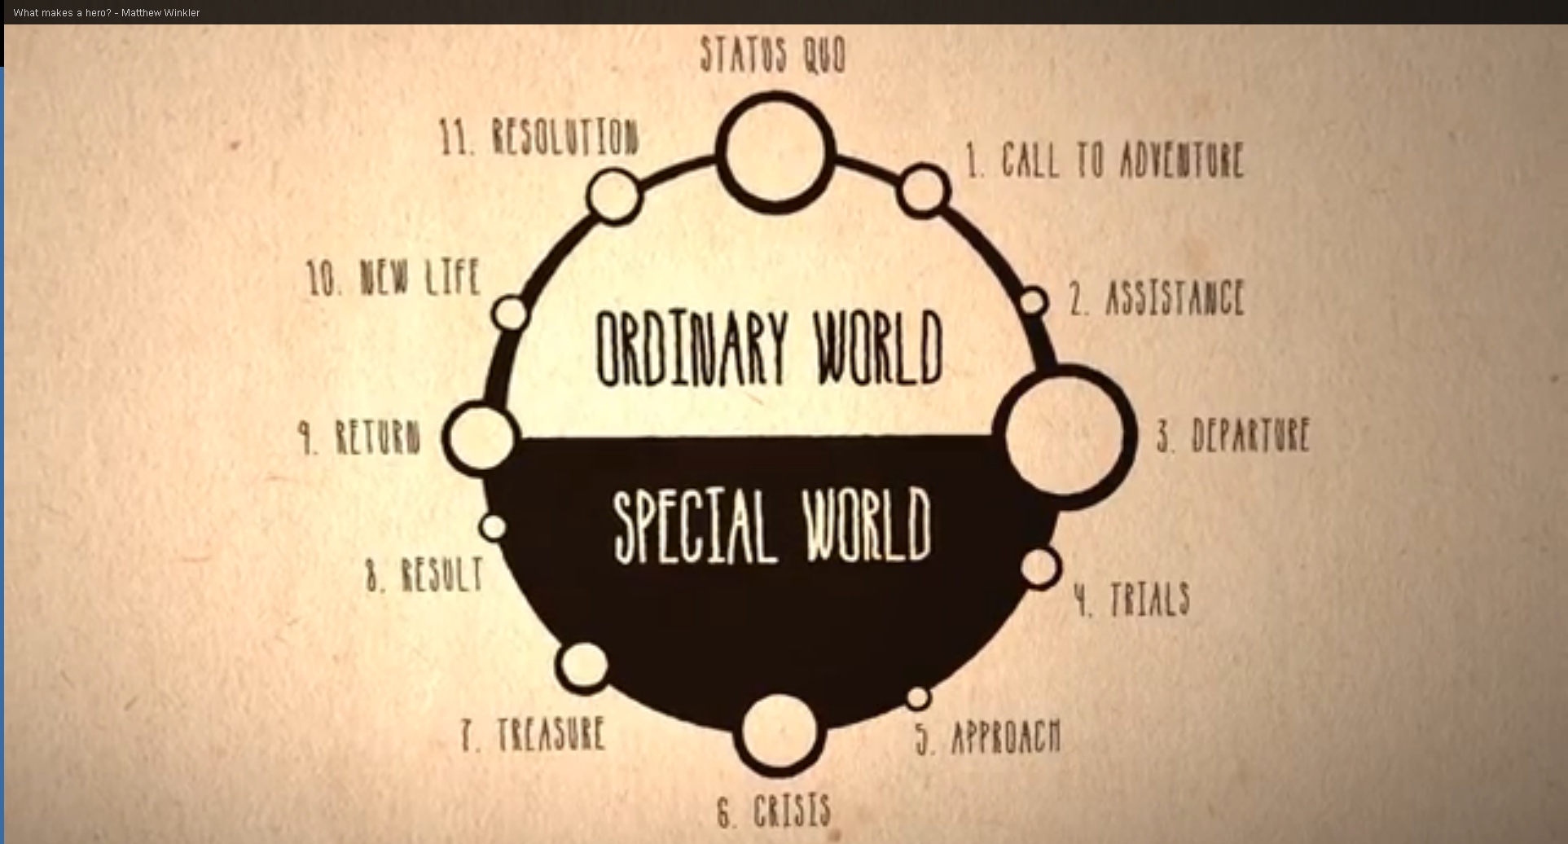

“The Hero’s Journey” – A Myth Analysis by Joseph Campbell

1:00 - Call to Adventure – Hero receives mysterious message or challenge.

2:00 – Assistance – Hero needs help from someone older and wiser.

3:00 – Departure – Hero leaves normal safe home and enters a world of adventure.

4:00 – Trials – Hero deals with difficult task, maybe slays a monster or escapes a trap.
5:00 – Approach – It is time for Hero to face his biggest fear.

6:00 – Crisis – Hero faces death, but survives.

7:00 – Treasure – Hero claims some treasure as a result of adventure, maybe special recognition.

8:00 – Result – What does the monster from the crisis scene do?

9:00 – Return – Hero returns to his ordinary world.

10:00 – New Life – Quest has changed Hero – He has outgrown old life.

11:00 – Resolution – All tangled plot lines are tied up.

12:00 – Status Quo – upgraded to new level. Nothing can be quite the same.

Name ________________________________

Now that you have considered The Hero’s Journey, you are being asked to decide if The Odyssey fits into this pattern. Complete the following organizer with info from what we have read so far.

1:00 – Call to Adventure | 2:00 - Assistance
3:00 – Departure | 4:00 - Trials
5:00 – Approach | 6:00 Crisis
7:00 Treasure | 8:00 Result
9:00 Return | 10:00 New Life
11:00 – Resolution | 12:00 Status Quo

