WESTERVILLE CITY SCHOOLS
Department of Purchasing & Logistics
Kari Dennis, Manager
Food Service and Purchasing
Lonnie Robinson, Secretary
614/797-5993 office; 614/797-5951 fax
www.wcsoh.org
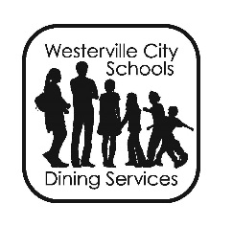
LOST/FORGOTTEN SCHOOL BREAKFAST/LUNCH MONEY
Westerville City Schools recognizes that occasionally a student may forget, lose and/or encounter a zero cash balance in a student’s personal breakfast/lunch account fund. The Office of Purchasing & Logistics is dedicated to ensuring that students are provided the opportunity to eat a nutritious breakfast and/or lunch at school – as there is a positive correlation between a healthy diet and academic success. Additionally, Food Service will continue to operate in a fiscally responsible manner. WCS Food Service operations are self-funded. Please reference the Administrative Guidelines as posted on the district website under the Food Service Department for additional information on this guideline.
ON LINE DEBIT/CREDIT CARD PAYMENT SYSTEM

SPS EZPay is a secure and convenient website application that allows parents to add to their child’s meal account, pay school, class and activity fees, and Pre-School and Full Day Kindergarten Tuition over the Internet using any Visa or MasterCard (including Debit Visa and MasterCard). Please note that Food Service cannot take credit card payments at our office or at the schools; this is only available over the Internet. The use of EZPay is optional; we will continue to accept cash and checks for payment of fees or deposits into meal accounts.

There is a $2.50 per transaction fee. You may deposit into multiple student accounts and also make fee payments in “one” transaction. More detailed instructions on using the EZPay website can be found on the district website in the Food Services Departmental information section, or you may visit www.spsezpay.com/westerville.

If you are a current EZPay user, please note that EZPay is making some changes to accommodate more mobile device users.

Your current login screen looks like this.
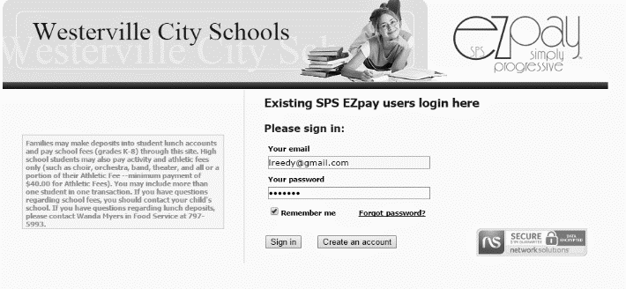
Your new login screen will look like this...
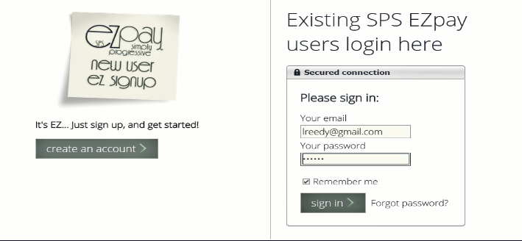

BIOMETRIC FINGER SCANNING: Food Service has implemented the Biometric Finger Scanning software which we hope will eliminate falsification of student ID’s as well as increase the speed of our lines. Incoming students will be set up with their accounts during back to school days or during the first weeks of school.

FOOD ALLERGIES: Do you have a child with food allergies? Please visit the district website, follow the links to the Food Service Department, and you will find important information that is needed in order to make food substitutions in the cafeteria.
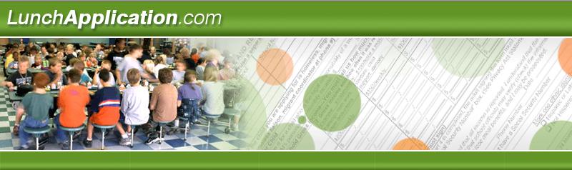
YOU CAN APPLY NOW!
AVOID THE RUSH AND THE DELAY!

Westerville City Schools is in its third year where families can apply on-line for your children to receive free or reduced price school meals. Your application will be sent from a secure website directly to Westerville City Schools. Your personal information remains confidential and secure. www.LunchApplication.com has been designed to make it easy for you to know exactly what information you will need to guide you through the process. Once your application has been received, the district office will determine your eligibility and will send you a letter with the results. www.LunchApplication.com is an easy, secure, and convenient way to apply for free or reduced price school meals. Please note that if you receive a letter from Food Service regarding Direct Certification, you do NOT need to submit an application as you have already been approved. These notifications will start going home between July 20 and July 27 via US Mail.

TO APPLY: Simply go to www.LunchApplication.com and click on APPLY NOW then follow all the prompts. You should have the six digit student ID number for each child on the application. Paper applications are available at your child’s school, the Food Service office located at 125 E. Walnut Street (Transportation & Logistics Building) or the Westerville Enrollment Center at 300 Polaris Parkway, Suite 3200. You may also access the application through the district website.

MEAL PRICING:

Elementary: $2.60 Lunch $1.25 Breakfast Reduced Meals: $0.40/Lunch
Middle/High: $2.85 Lunch $1.50 Breakfast Reduced Meals: $0.40/Lunch

START your day the right way with School Breakfast!
School Breakfast will give you MORE energy, keep your body healthy, and help
improve your grades! Westerville City Schools offers breakfast daily.

Breakfast times are as follows:
Elementary* – 8:45- 9:05 AM - $1.25**
Middle – 7:35 - 8:00 AM - $1.50**
High – 7:00 - 7:25 AM - $1.50**

As a sponsor of the National School Breakfast and Lunch Program, Westerville City Schools must abide by the USDA regulations in the administration of this program. USDA is an equal opportunity provider and employer.

*Elementary times may vary from building to building by 5 minutes. Please check with your child’s school for exact times.
**No charge to students qualifying under the USDA Eligibility Guidelines of the National School Lunch Program.

